18 November 2021
Nigeria: Recent spate of vessels suffering from hidden drugs in cargo and its consequences

2021 has seen several vessels being arrested in Nigeria following finds of drugs in Raw Sugar cargo loaded in Santos, Brazil when being discharged in Lagos. The smuggling seems to follow a pattern whereby parcels 1 Kg blocks of cocaine in 30 to 40 Kg parcels are concealed in the cargo to be collected during or before discharge.

Outer parcels | Contents
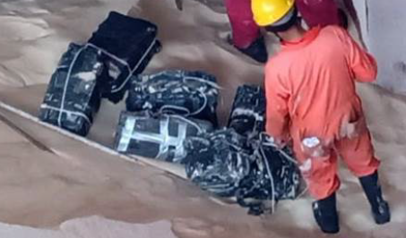 | 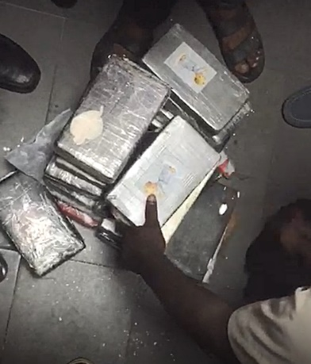

The stowing of the drugs appears to be a clandestine operation by smugglers climbing over the vessel sides from the seaward side and planting the parcels of drugs in the cargo out of view. Several vessels detected drugs in the cargo when hatch seals were found damaged or the smugglers were spotted on deck. Extensive searches of the cargo revealed drugs of up to 150 Kg, which were landed. The searches included deep cargo probing, sniffer dogs and underwater searches. Unfortunately in 2 cases not all drugs were found and smaller parcels appeared when discharged.

The Nigerian Authorities were alerted by Interpol who monitored the progress of the vessels ex Santos. The first discovery was in February 2021 when about 40 Kg of Cocaine was discovered ashore and claimed to have been discharged onto a hopper by grab. The crew and vessel were arrested and after much negotiation the vessel and all but the crew on watch on the date of the find were released. The 6 crew are still under arrest late November 2021 awaiting the end of the trial.

Further cases of discoveries of drugs in the cargo in Santos came to light but the vessels discharged cargo without further incident. In early October and early November 2021, 2 vessels berthed at Lagos after drugs were discovered at load port. Despite searches being carried out before sailing there were subsequent finds of smaller parcels of drugs which remained undetected in Santos. These vessels were both destined for the same Receiver and Terminal and were promptly arrested when the Nigerian Navy, NDLEA, Customs and Interpol sighted drugs during discharge. The vessels had been boarded on arrival but since the vessels had thought the drug smuggling had been thwarted after the search in Santos there were no alarms raised for local P&I Correspondents in Nigeria.

Dog search in Santos | Probing for drugs after loading
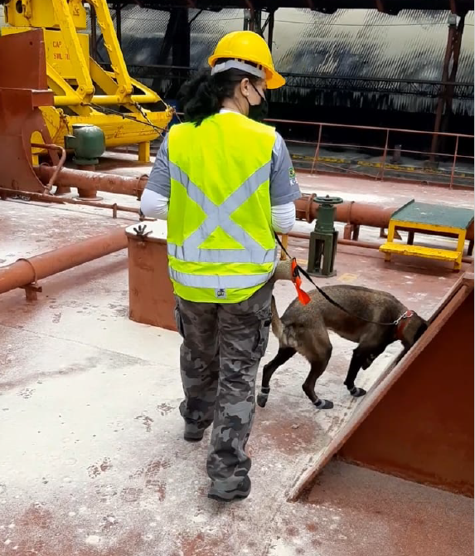 | 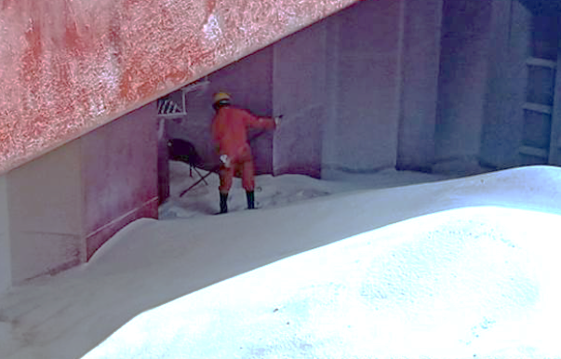

The problem of vessels innocently used as “drug mules” is extensive and the repercussions when drugs are discovered in Nigeria are a disaster for the owners and crew.

Despite the threat of punitive sentences and fines for the crew and vessels by the extremely slow Nigerian judicial system, there are prospects of massive claims from Terminal and Receivers for alleged losses claimed to have been caused by the vessel being arrested on the berth.

In the cases of raw sugar cargo vessels the matters are still ongoing with 2 vessels and crew detained until further notice. The crew are incommunicado and being denied access to lawyers and other agencies. All attempts to get basic human rights enforced have been thwarted.

Therefore intricate security measures need to be in place when loading Raw Sugar such as 24 hour guards on the cargo throughout loading and thorough CCTV coverage of upperdeck and hatches are measures that should be considered. A post discharge exploratory dive under the hull should be carried out.

